**UNIT-II**

**D.C. Circuits:** Mesh and Nodal Analysis with independent sources – Numerical problems.

**Network Theorems:** Superposition, Reciprocity and Thevinin’s Theorem with independent sources, Simple problems.

---------------------------------------------------------------------------------------------------------------------

**Mesh and Nodal Analysis with independent sources**

This post answers the question “What is mesh and node analysis”. This two techniques are both used as basic analysis methods for circuits. When designing a complex electrical device there are a lot of factors that occur, like current leaks, heat flow, electromagnetic fields, behaviour of electrical materials etc.

In any case it’s always helpful to replace existing schemes by an equivalent network, where components are ideal. For instance, it’s easier to analyse an electric circuit when single sources, loads and passive elements are replaced with current and voltage sources and resistors. You will see below how to simplify analysis of complex circuits. It appears easier to calculate the scheme parameters counter posing a complex circuit and its equivalent analogue network. The nodal, mesh, loop and superposition methods will be discovered.

**Nodal Analysis**

We discovered above the way of analyzing simple circuits with two or three nodes. The nodal method will allow us to analyse circuits with four and more nodes in it. By the calculations above we found out the quantity on variable, voltages and equations will be , where n is quantity of nodes in a circuit.

In the nodal method we are finding the node voltages with the following steps:

1. Select a reference node. Assign all the rest nodes voltages, with respect to reference node.
2. Use Kirchhoff’s and Ohm’s Laws to each non-reference node and branch currents.
3. Resolve the system of equations and obtain node voltages.

Let us discover the three node circuits in the Figure. There are two current sources and three resistors.

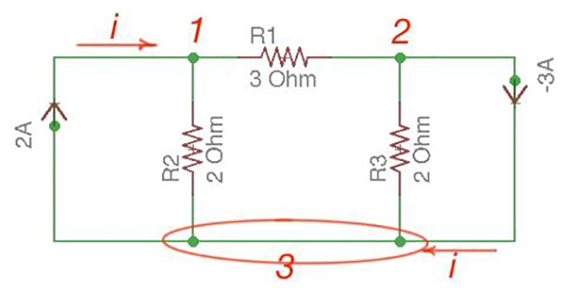

Figure

Let us consider a reference node – 3. In a real circuit a reference node is ground, it is assumed to have potential. A reference node can also be the one with the biggest quantity of connected branches like in our case.

By the Kirchhoff’s Law having the following current relation:

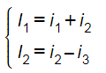

Let us represent currents like ratio of voltage and resistance by the Ohm’s Law:

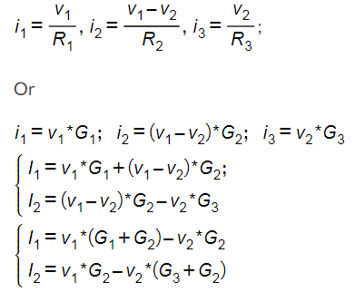

And we achieve the following matrix equation, which can be resolved by the Cramer’s rule:

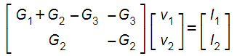

Here a symmetric circuit was resolved. Let us consider a non-symmetric circuit – with a voltage source in a system.

Let us consider the scheme in the Figure.

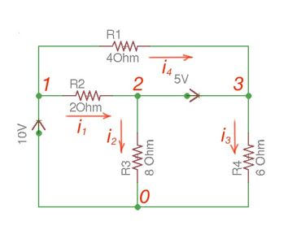

Figure

There are two possibilities that exist:

1. If the voltage source is between reference node and non-reference node, the non-reference voltage is considered equal to the voltage source.
2. If the voltage source is between two non-reference nodes, these two nodes are considered to be generalized nodes. To determine its voltage Kirchhoff’s Laws must be applied.

Applying Kirchhoff’s Laws we achieve the following equations:

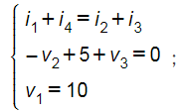

By the Ohm’s Law:

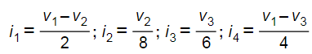

These equations will help to determine node voltages.

The node method is a very generalized method of circuits analysis. This method can be applied to any circuit. However, it’s not the only one. Here below is the most commonly used method – Mesh method. It can also be applied to a lot of circuits and is considered as the most popular method.

**Mesh Analysis**

Mesh analysis is applicable to the networks which are planar. *Planar network* is a network where branches are not passing over or under each other.

This method differs from the nodal method by using mesh currents instead of nodal voltages as circuit variables. This method is convenient as it allows us to reduce the number of equations that must be solved simultaneously. Nodal method uses Kirchhoff’s currents Law to consider nodal voltages, and Mesh method uses Kirchhoff’s voltages Law to consider mesh currents. *Mesh* is a loop, which does not contain any other loops.

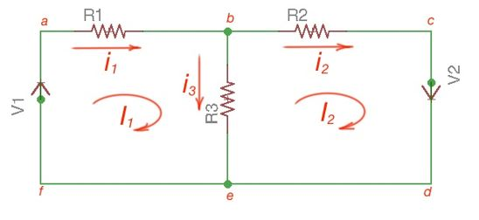

Figure

There are only two meshes in Figure – abefa and bcdeb, abcdefa is not a mesh but a loop and Kirchhoff’s Laws work here. However, for Mesh method only meshes are in use.

Mesh analysis steps are the following:

1. Assign mesh currents to all the meshes in a circuit.
2. Apply Kirchhoff’s voltage Law to each mesh. Apply Ohm’s Law to determine voltages with mesh currents.
3. To resolve simultaneously all the equations to consider mesh currents.

Note that directions of mesh currents are arbitrary, but it is better to suggest that they are all clock-wise (or vice versa), to avoid mistakes with signs in equations.

The following equations correspond to the Kirchhoff’s Voltage Laws for the meshes:

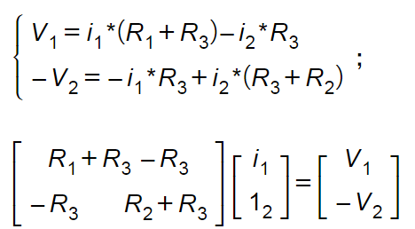

Using Cramer’s formula for resolving the matrix equations above we can find mesh currents, which allow us to consider currents in a circuit.



Current sources in a circuit will bring asymmetry in our equations and calculations. If there are current sources in the circuit, they have to be replaced by open circuits. The source currents should be considered as depending on the number of sources. Kirchhoff’s voltage Law can be applied for the closed circuits/meshes. Simultaneously resolving this equation, circuits and mesh currents will be resolved.

**Numerical Problems**

**https://www.solved-problems.com/circuits/electrical-circuits-problems/resistive-circuits/1438/mesh-current-analysis-problem/**

### Steps to analyze the mesh analysis technique

1) Check whether there is a possibility to transform all current sources in the given circuit to voltage sources.

2) Assign the current directions to each mesh in a given circuit and follow the same direction for each mesh.

3) Apply KVL to each mesh and simplify the KVL equations.

4) Solve the simultaneous equations of various meshes to get the mesh currents and these equations       are exactly equal to the number of meshes present in the network.

   Consider the below DC circuit to apply the mesh current analysis, such that currents in different meshes can be found. In the below figure there are three meshes present as ACDA, CBDC and ABCA but the path ABDA is not a mesh. As a first step, the current through each mesh is assigned with the same direction as shown in figure.

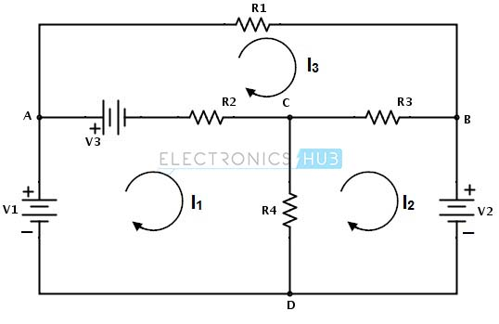

Secondly, for each mesh we have to apply KVL. By applying KVL around the first loop or mesh we get

V1 − V3 − R2 ( I1 − I 3 ) − R4 ( I1 − I 2 ) = 0

V1 − V3 = I1 ( R2 + R4 ) − I2R4 − I3R2 ………………(1)

Similarly , by applying KVL around second mesh we get,

−V2 − R3 ( I 2 − I 3 ) − R4 ( I 2 − I1 ) = 0

− V2 = − I1R4 + I 2 ( R3 + R4 ) − I 3 R3 ………………………(2)

And by applying KVL around third mesh or loop we get,

V3 − R1I 3 − R3( I 3 − I 2 ) − R2( I 3 − I1 ) = 0

V3 = − I1R2 − I2R3 + I3(R1 + R2 + R3) ………………………(3)

Therefore, by solving the above three equations we can obtain the mesh currents for each mesh in the given circuit.

**Example 1:**

Consider the below example in which we find the voltage across the 12A current source using mesh analysis. In the given circuit all the sources are current sources.

[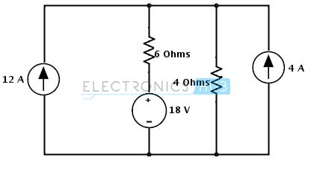](https://www.electronicshub.org/wp-content/uploads/2015/04/2.image2_.jpg)

**Step 1:** In the circuit there is a possibility to change the current source to a voltage source on right hand side source with parallel resistance. The current source is converted into a voltage source by placing the same value of resistor in series with a voltage source and the voltage in that source is determined as

Vs = Is Rs

= 4× 4 = 16 Volts

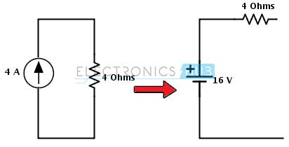

**Step 2:** Assign the branch currents as I1 and I2 to the respective branches or loops and represent the direction of currents as shown below.

[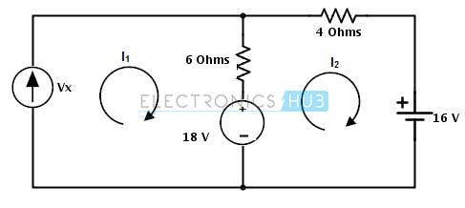](https://www.electronicshub.org/wp-content/uploads/2015/04/4.image4_.jpg)

**Step 3:** Apply the KVL to each mesh in the given circuit

**Mesh -1:**

Vx − 6 × (I1 − I 2) − 18 = 0

Substituting I1 = 12 A

Vx + 6I2 = 90…………………… (1)

**Mesh – 2:**

18 − 6 × ( I 2 − I1 ) − 4 × I 2 − 16 = 0

2 – 10 × I2 + 6(12) = 0

I2 = 74/ 10

= 7.4 Amps

Substituting in equation 1 we get

Vx = 90 – 44.4

= 45.6 Volts

**Example 2:**

Consider the below circuit where we determine the voltage across the current source and a branch current Iac. Assign the directions as shown below and note that current is assigned opposite to the source current in second loop.

By applying KVL to the first mesh we get

V1 − R2 ( I1 − I 3 ) − R4 ( I1 − I 2 ) = 0

[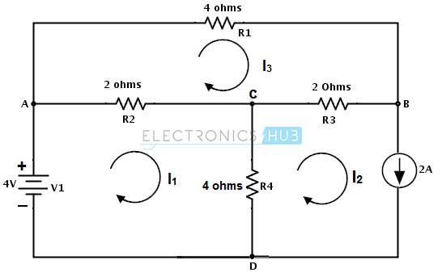](https://www.electronicshub.org/wp-content/uploads/2015/04/5.image5_.jpg)

4 – 2 I1 − 2I3 − 4I1 − 4I2 = 0

-6I1 − 2I3 = 4 …………… (1)

By applying KVL to the second mesh we get

−Vc − R4( I 2 − I1 ) − R3 ( I 2 − I 3 ) = 0

– Vc = 4I2 − 4I1 + 2I2 − 2I3 = 0

– Vc = – 4I1 + 6I2 – 2I3

But I2 = -2 A, then

– Vc = – 4I1 – 12 – 2 I3 …………………. (2)

By applying KVL to the third mesh we get

− R1 I 3 − R3 ( I 3 − I 2 ) − R2 ( I 3 − I1 ) = 0

−4 I3 − 2I3 + 2I2 − 2I3 + 2I1 = 0

− 8I3 − 4 + 2I1 = 0 (by substituting I2 = -2 A)

2I1 − 8I3 = 4 …………………(3)

By solving 1 and 3 equations we get I3 = -0.615 and I1 = 4.46

Therefore, the voltage Vc = 4 (4.46) + 12 + 2(-0.615)

Vc = 28.61 V

And the branch current Iac = I1- I3

Iac = 5.075 amps

Likewise we can find every branch current using the mesh analysis.

**Network Theorems**

**Superposition theorem**

**Superposition theorem** states that in any linear, active, bilateral network having more than one source, the response across any element is the sum of the responses obtained from each source considered separately and all other sources are replaced by their internal resistance. The superposition theorem is used to solve the network where two or more sources are present and connected.

It is only applicable to the circuit which is valid for the [ohm’s law](https://circuitglobe.com/ohms-law.html) (i.e., for the linear circuit).

## Explanation of Superposition Theorem

Let us understand the superposition theorem with the help of an example. The circuit diagram is shown below consists of two voltage sources V1and V2.

[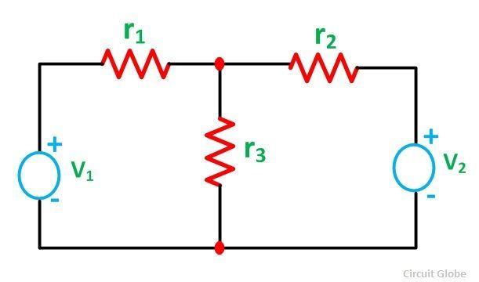](https://circuitglobe.com/wp-content/uploads/2015/10/Superposition-theorem-figure-1-compressor.jpg)

First, take the source V1alone and short circuit the V2source as shown in the circuit diagram below:

[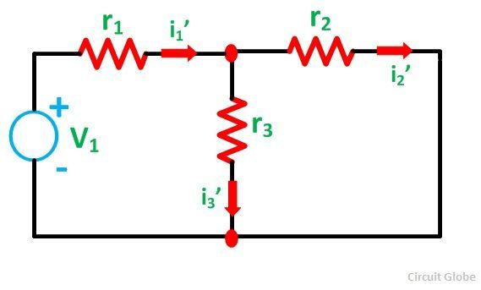](https://circuitglobe.com/wp-content/uploads/2015/10/Superposition-theorem-figure-2-compressor.jpg)

Here, the value of current flowing in each branch, i.e. i1’, i2’ and i3’ is calculated by the following equations.

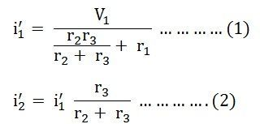

The difference between the above two equations gives the value of the current i3’

[superposition-theorem-eq2](https://circuitglobe.com/wp-content/uploads/2015/10/superposition-theorem-eq2-compressor.jpg)

Now, activating the voltage source V2and deactivating the voltage source V1 by short-circuiting it, find the various currents, i.e. i1’’, i2’’, i3’’ flowing in the circuit diagram shown below:

[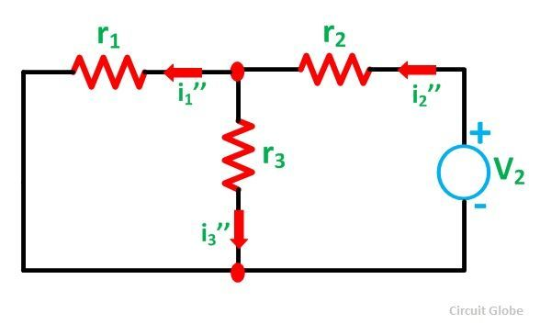](https://circuitglobe.com/wp-content/uploads/2015/10/Superposition-theorem-figure-3-compressor1.jpg)

Here,

[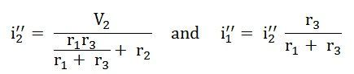](https://circuitglobe.com/wp-content/uploads/2015/10/superposition-theorem-eq3-compressor.jpg)

And the value of the current i3’’ will be calculated by the equation shown below:

[superposition-theorem-eq4](https://circuitglobe.com/wp-content/uploads/2015/10/superposition-theorem-eq4-jpg-compressor.jpg)

As per the superposition theorem, the value of current i1, i2, i3 is now calculated as:

[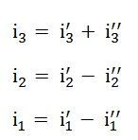](https://circuitglobe.com/wp-content/uploads/2015/10/superposition-theorem-eq5-compressor.jpg)

The direction of the current should be taken care of while finding the current in the various branches.

## Steps for solving network by Superposition Theorem

Considering the circuit diagram A, let us see the various steps to solve the superposition theorem:

[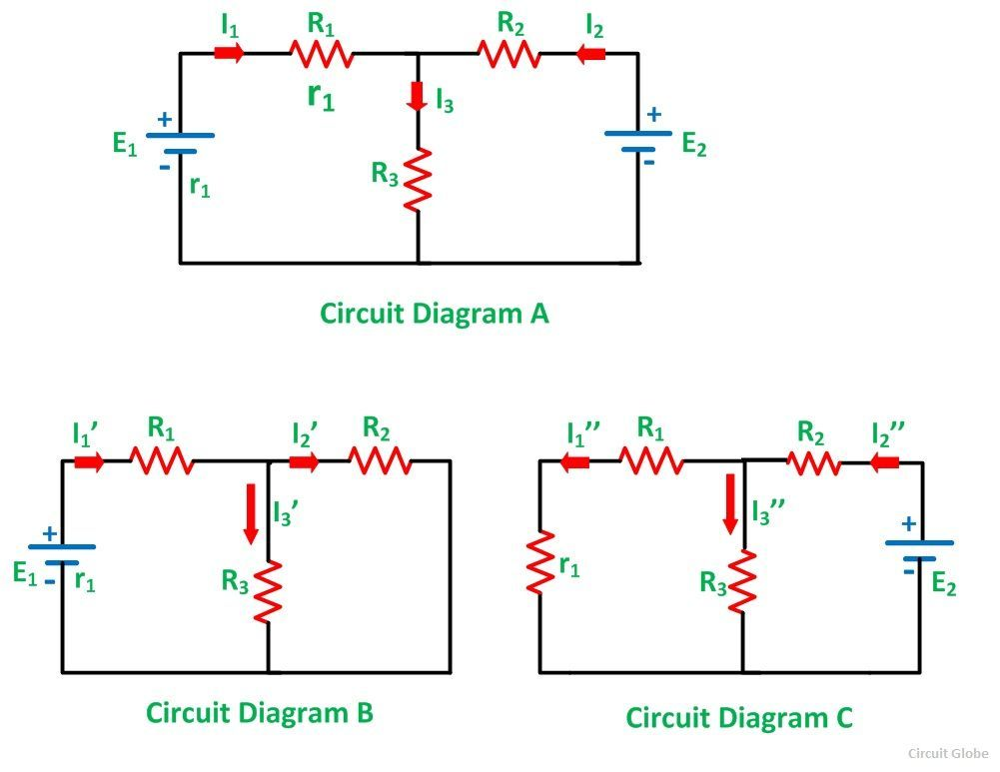](https://circuitglobe.com/wp-content/uploads/2015/10/Superposition-theorem-figure-4-compressor.jpg)

**Step 1 –** Take only one independent source of voltage or current and deactivate the other sources.

**Step 2 –** In the circuit diagram B shown above, consider the source E1 and replace the other source E2 by its internal resistance. If its internal resistance is not given, then it is taken as zero and the source is short-circuited.

**Step 3 –** If there is a voltage source than short circuit it and if there is a current source then just open circuit it.

**Step 4 –** Thus, by activating one source and deactivating the other source find the current in each branch of the network. Taking the above example find the current I1’, I2’and I3’.

**Step 5 –** Now consider the other source E2 and replace the source E1 by its internal resistance r1as shown in the circuit diagram C.

**Step 6 –** Determine the current in various sections, I1’’, I2’’ and I3’’.

**Step 7 –** Now to determine the net branch current utilizing the superposition theorem, add the currents obtained from each individual source for each branch.

**Step 8 –** If the current obtained by each branch is in the same direction then add them and if it is in the opposite direction, subtract them to obtain the net current in each branch.

### The actual flow of current in the circuit C will be given by the equations shown below:

### [superposition-theorem-eq6](https://circuitglobe.com/wp-content/uploads/2015/10/superposition-theorem-eq6-compressor.jpg)

### Example

Find the current flowing through 20 Ω resistor of the following circuit using **superposition theorem**.

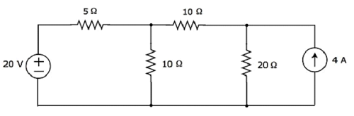

**Step 1** − Let us find the current flowing through 20 Ω resistor by considering only **20 V voltage source**. In this case, we can eliminate the 4 A current source by making open circuit of it. The modified circuit diagram is shown in the following figure.

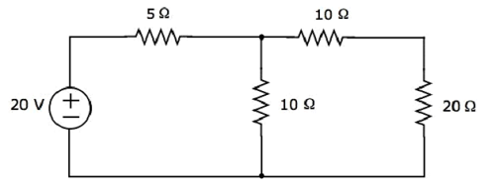

There is only one principal node except Ground in the above circuit. So, we can use **nodal analysis** method. The node voltage V1 is labelled in the following figure. Here, V1 is the voltage from node 1 with respect to ground.

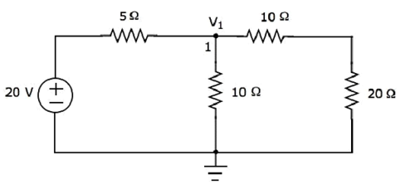

The **nodal equation** at node 1 is

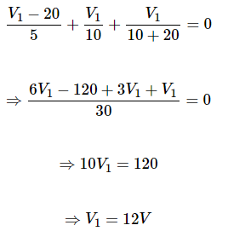

The **current flowing through 20 Ω resistor** can be found by doing the following simplification.



Substitute the value of V1 in the above equation.



Therefore, the current flowing through 20 Ω resistor is **0.4 A**, when only 20 V voltage source is considered.

**Step 2** − Let us find the current flowing through 20 Ω resistor by considering only **4 A current source**. In this case, we can eliminate the 20 V voltage source by making short-circuit of it. The modified circuit diagram is shown in the following figure.

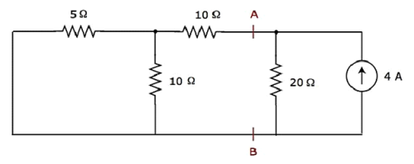

In the above circuit, there are three resistors to the left of terminals A & B. We can replace these resistors with a single **equivalent resistor**. Here, 5 Ω & 10 Ω resistors are connected in parallel and the entire combination is in series with 10 Ω resistor.

The **equivalent resistance** to the left of terminals A & B will be

# 

The simplified circuit diagram is shown in the following figure.

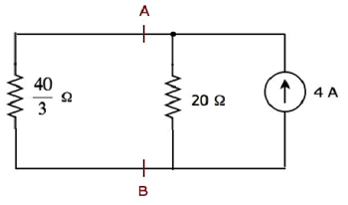

We can find the current flowing through 20 Ω resistor, by using **current division principle**.

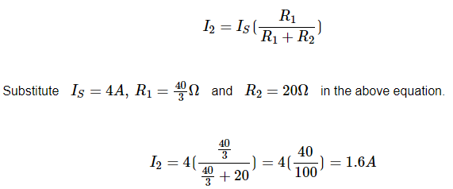

Therefore, the current flowing through 20 Ω resistor is **1.6 A**, when only 4 A current source is considered.

**Step 3** − We will get the current flowing through 20 Ω resistor of the given circuit by doing the **addition of two currents** that we got in step 1 and step 2. Mathematically, it can be written as

I=I1+I2

Substitute, the values of *I1* and *I2* in the above equation.

I=0.4+1.6=2A

Therefore, the current flowing through 20 Ω resistor of given circuit is **2 A**.

**Note** − We can’t apply superposition theorem directly in order to find the amount of **power** delivered to any resistor that is present in a linear circuit, just by doing the addition of powers delivered to that resistor due to each independent source. Rather, we can calculate either total current flowing through or voltage across that resistor by using superposition theorem and from that, we can calculate the amount of power delivered to that resistor using I2R or V2/R

# Thevenin’s Theorem

**Thevenin’s Theorem** states that any complicated network across its load terminals can be substituted by a voltage source with one resistance in series. This theorem helps in the study of the variation of current in a particular branch when the resistance of the branch is varied while the remaining network remains the same.

For example in designing electrical and electronics circuits.

A more general statement of Thevenin’s Theorem is that any linear active network consisting of independent or dependent voltage and current source and the network elements can be replaced by an equivalent circuit having a voltage source in series with a resistance.

Where the voltage source being the open-circuited voltage across the open-circuited load terminals and the resistance being the internal resistance of the source.

In other words, the current flowing through a resistor connected across any two terminals of a network by an equivalent circuit having a voltage source Eth in series with a resistor Rth. Where Eth is the open-circuit voltage between the required two terminals called the Thevenin voltage and the Rth is the equivalent resistance of the network as seen from the two-terminal with all other sources replaced by their internal resistances called Thevenin resistance.

## Explanation of Thevenin’s Theorem

The Thevenin’s statement is explained with the help of a circuit shown below:

[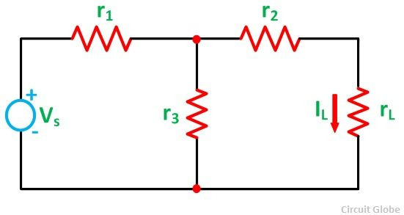](https://circuitglobe.com/wp-content/uploads/2015/10/Thevenins-Theorem-figure-1-compressor.jpg)

Let us consider a simple DC circuit as shown in the figure above, where we have to find the load current **IL** by the Thevenin’s theorem.

In order to find the equivalent voltage source,**rL** is removed from the circuit as shown in the figure below and **Voc** or **VTH** is calculated.

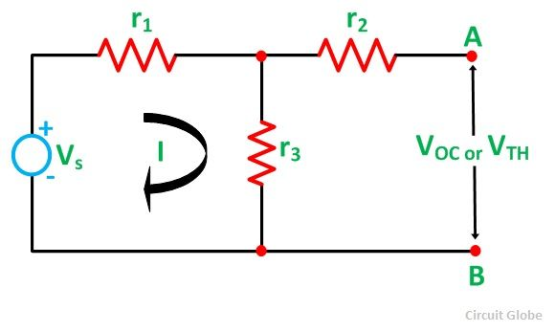

So,

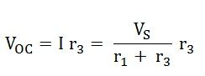

Now, to find the internal resistance of the network (Thevenin’s resistance or equivalent resistance) in series with the open-circuit voltage **VOC**, also known as Thevenin’s voltage **VTH**, the voltage source is removed or we can say it is deactivated by a short circuit (as the source does not have any internal resistance) as shown in the figure below:

[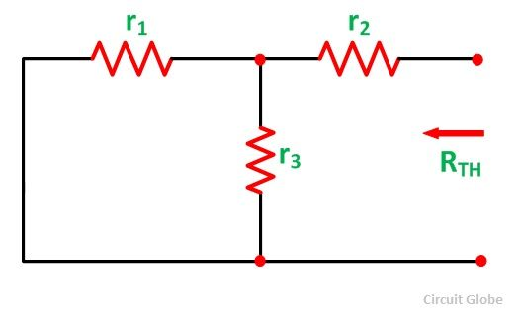](https://circuitglobe.com/wp-content/uploads/2015/10/Thevenins-Theorem-figure-3-compressor.jpg)

Therefore,

[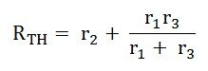](https://circuitglobe.com/wp-content/uploads/2015/10/THEVENINS-THEOREM-EQ2.jpg)

So,

[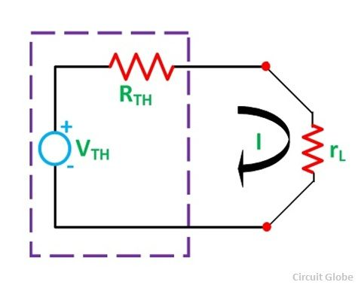](https://circuitglobe.com/wp-content/uploads/2015/10/Thevenins-Theorem-figure-4-compressor.jpg)

Equivalent Circuit of Thevenin’s Theorem

As per Thevenin’s Statement, the load current is determined by the circuit shown above and the equivalent Thevenin’s circuit is obtained.  
The load current **IL** is given as:

[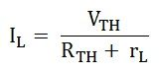](https://circuitglobe.com/wp-content/uploads/2015/10/THEVENINS-THEOREM-EQ3.jpg)

Where,

**VTH** is the Thevenin’s equivalent voltage. It is an open circuit voltage across the terminal AB known as **load terminal, RTH** is the Thevenin’s equivalent resistance, as seen from the load terminals where all the sources are replaced by their internal impedance **rL** is the **load resistance**  
**Steps for Solving Thevenin’s Theorem**

**Step 1 –** First of all remove the load resistance **rL** of the given circuit.

**Step 2 –**Replace all the sources by their internal resistance.

**Step 3 –** If sources are ideal then short circuit the voltage source and open circuit the current source.

**Step 4 –** Now find the equivalent resistance at the load terminals, known as Thevenin’s Resistance (RTH).

**Step 5 –** Draw the Thevenin’s equivalent circuit by connecting the load resistance and after that determine the desired response.

This theorem is possibly the most extensively used networks theorem. It is applicable where it is desired to determine the current through or voltage across any one element in a network. Thevenin’s Theorem is an easy way to solve a complicated network.

### Example

Find the current flowing through 20 Ω resistor by first finding a **Thevenin’s equivalent circuit** to the left of terminals A and B.

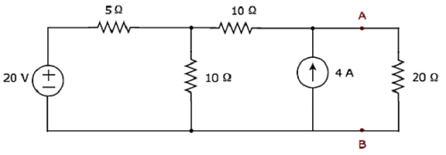

**Step 1** − In order to find the Thevenin’s equivalent circuit to the left side of terminals A & B, we should remove the 20 Ω resistor from the network by **opening the terminals A & B**. The modified circuit diagram is shown in the following figure.

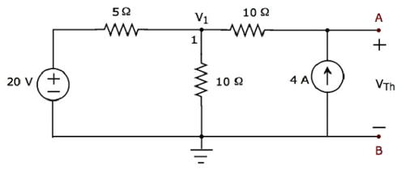

**Step 2** − Calculation of **Thevenin’s voltage VTh**.

There is only one principal node except Ground in the above circuit. So, we can use **nodal analysis** method. The node voltage V1 and Thevenin’s voltage VTh are labelled in the above figure. Here, V1 is the voltage from node 1 with respect to Ground and VTh is the voltage across 4 A current source.

* The **nodal equation** at node 1 is

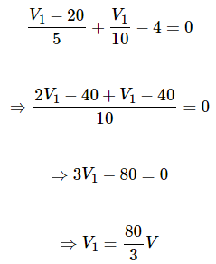

The voltage across series branch 10 Ω resistor is



There are two meshes in the above circuit. The KVL equation around second mesh is



Substitute the values of V1 and V10Ω in the above equation

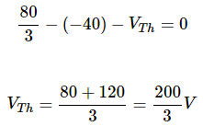



**Step 3** − Calculation of **Thevenin’s resistance RTh**.

Short circuit the voltage source and open circuit the current source of the above circuit in order to calculate the Thevenin’s resistance RTh across the terminals A & B. The **modified circuit diagram** is shown in the following figure.

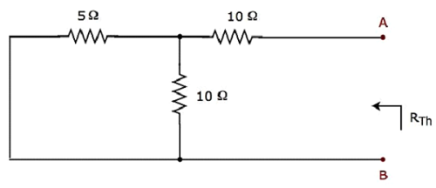

The Thevenin’s resistance across terminals A & B will be





**Step 4** − The Thevenin’s equivalent circuit is placed to the left of terminals A & B in the given circuit. This circuit diagram is shown in the following figure.

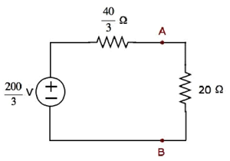

The current flowing through the 20 Ω resistor can be found by substituting the values of *VTh, RTh* and *R* in the following equation.

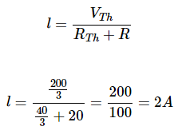



**Reciprocity Theorem**

**Reciprocity Theorem** states that – In any branch of a network or circuit, the current due to a single source of voltage (V) in the network is equal to the current through that branch in which the source was originally placed when the source is again put in the branch in which the current was originally obtained. This theorem is used in the bilateral linear network which consists of bilateral components.

In simple words, we can state the reciprocity theorem as when the places of voltage and current source in any network are interchanged the amount or magnitude of current and voltage flowing in the circuit remains the same.

This theorem is used for solving many DC and AC network which have many applications in electromagnetism electronics. These circuits do not have any time-varying element.

## Explanation of Reciprocity Theorem

The location of the voltage source and the current source may be interchanged without a change in current. However, the polarity of the voltage source should be identical with the direction of the branch current in each position.

The Reciprocity Theorem is explained with the help of the circuit diagram shown below

[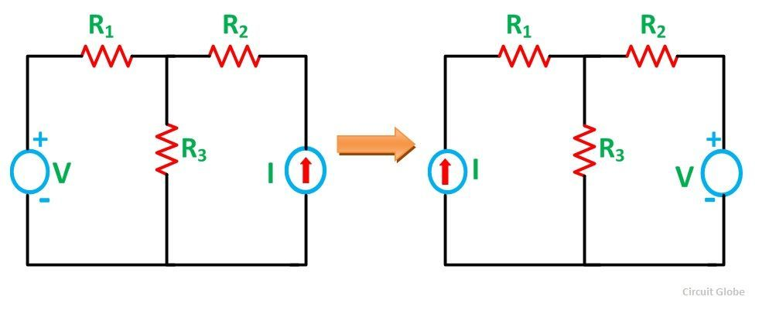](https://circuitglobe.com/wp-content/uploads/2015/10/reciprocity-theorem-fig-compressor.jpg)

The various resistances R1, R2, R3 is connected in the circuit diagram above with a voltage source (V) and a current source (I). It is clear from the figure above that the voltage source and current sources are interchanged for solving the network with the help of Reciprocity Theorem.

The limitation of this theorem is that it is applicable only to single-source networks and not in the multi-source network. The network where reciprocity theorem is applied should be linear and consist of resistors, inductors, capacitors and coupled circuits. The circuit should not have any time-varying elements.

## Steps for Solving a Network Utilizing Reciprocity Theorem

**Step 1 –** Firstly, select the branches between which reciprocity has to be established.

**Step 2 –** The current in the branch is obtained using any conventional network analysis method.

**Step 3 –** The voltage source is interchanged between the branch which is selected.

**Step 4 –** The current in the branch where the voltage source was existing earlier is calculated.

**Step 5 –** Now, it is seen that the current obtained in the previous connection, i.e., in step 2 and the current which is calculated when the source is interchanged, i.e., in step 4 are identical to each other.

**Example: Show the application of reciprocity theorem in the network of figure 1.**

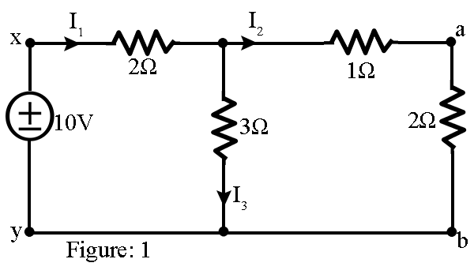

**Solution:**

With the reference to figure 1, the equivalent resistance across x-y is given by

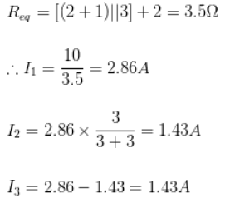

with reference to figure 2,

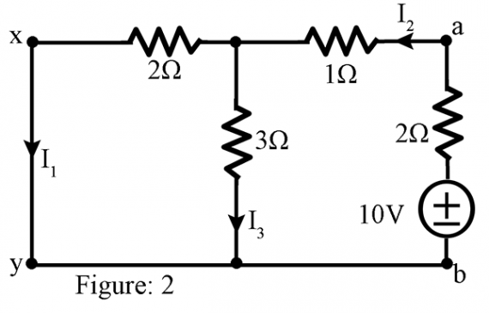

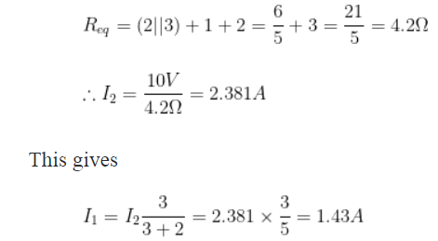

Hence we observe that when the sources was in branch x-y as in figure 1, the a-b branch current is 1.43A; again when the source is in branch a-b (figure 2), the x-y branch current becomes 1.43A. This proves the reciprocity theorem.

**https://electronicspani.com/reciprocity-theorem-example-with-solution/**